Issue 1 - Resolved issue of not showing dates after search in admin panel **DONE**

Issue 2 - End date will be greater than start date in Admin -> Dashboard (search feature) **DONE**

Issue 3 - Admin panel – Create ticket - Renewal date is greater than Expiry date **DONE**

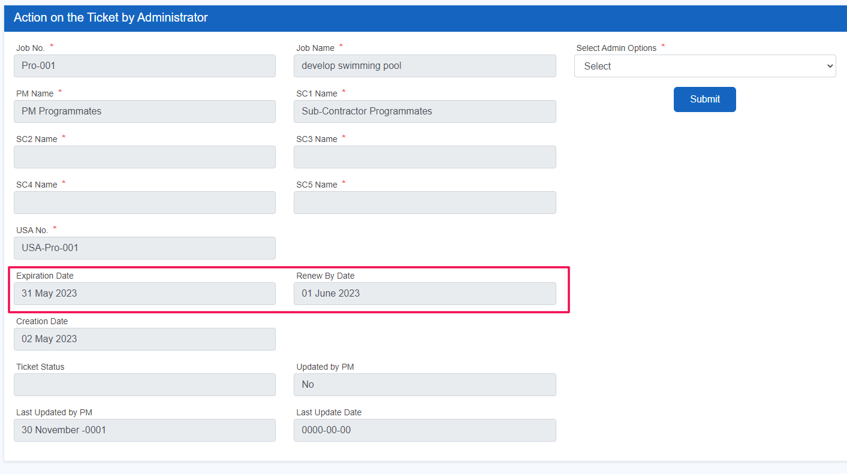

Issue 4 - Admin panel – Create ticket – Ticket created without sub contractor **DONE**

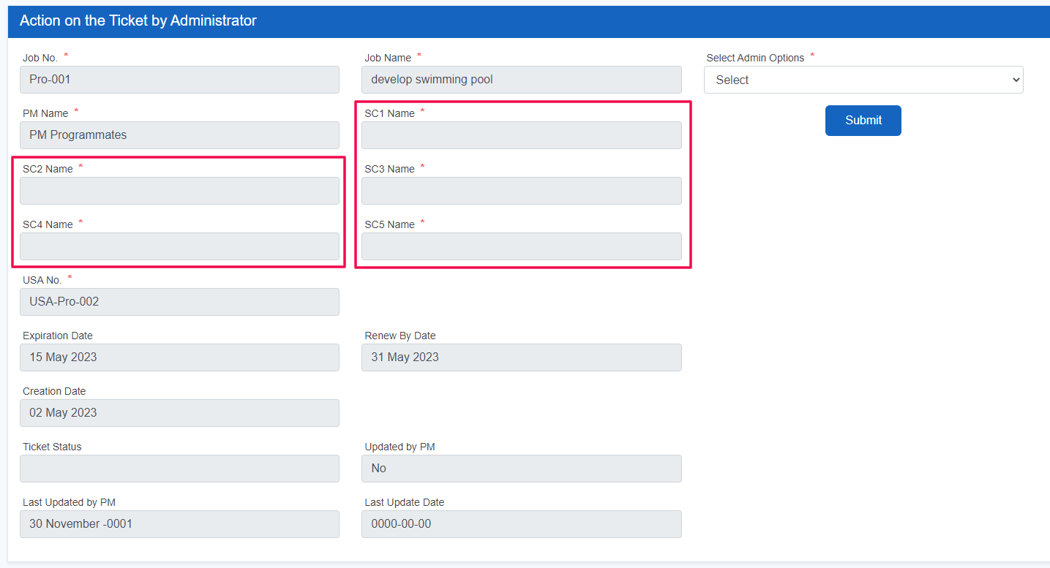

Issue 5 - Admin panel – Edit ticket – Wrong date at “Last updated by PM” and this ticket not updated by PM **DONE**

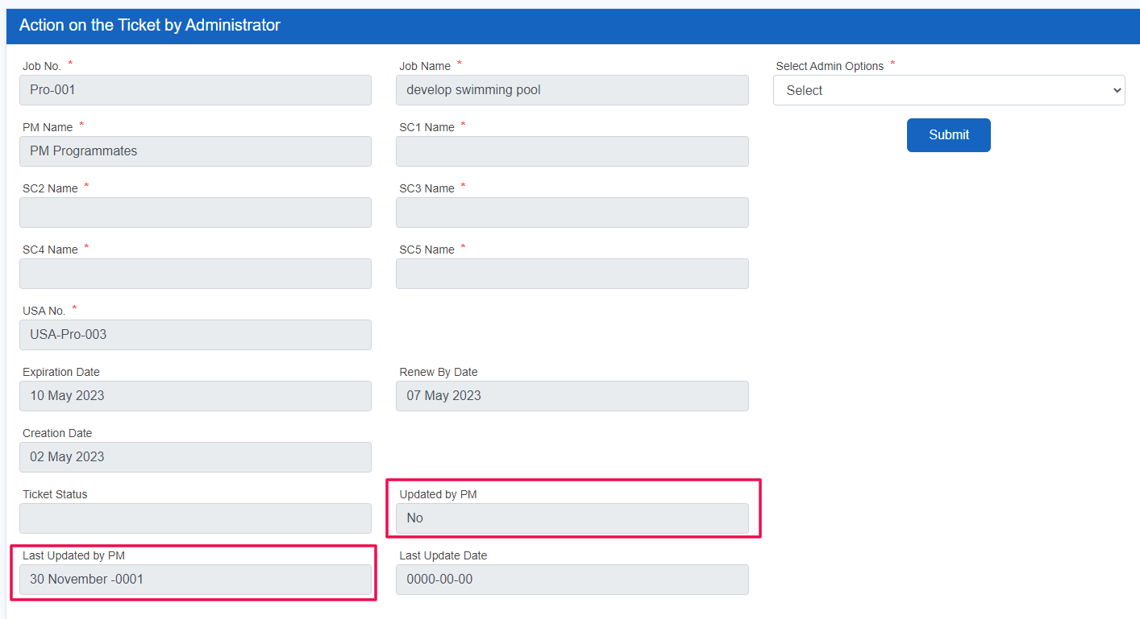

Issue 6 - Admin panel – create ticket – older dates are available

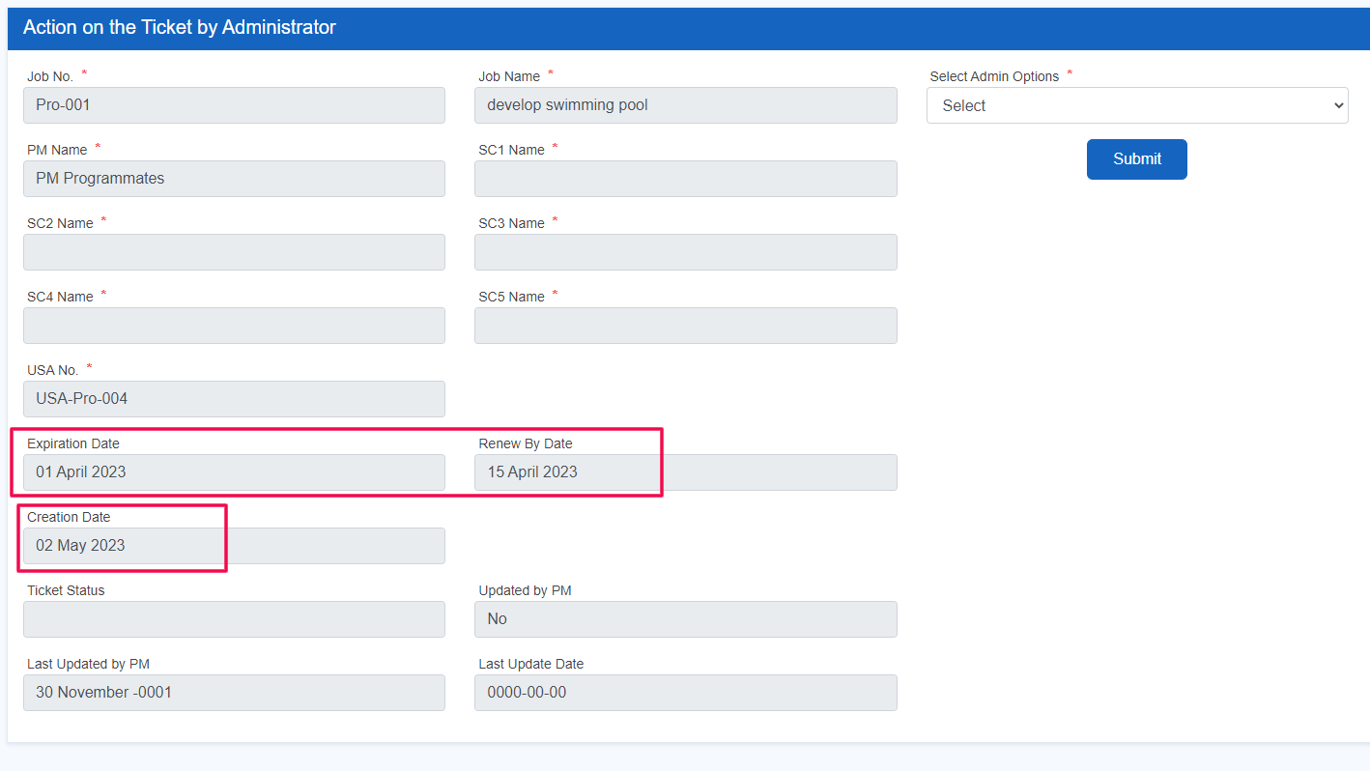

Issue 7 - Admin panel – Change password – not able to change password getting error – “current password is incorrect” **DONE**

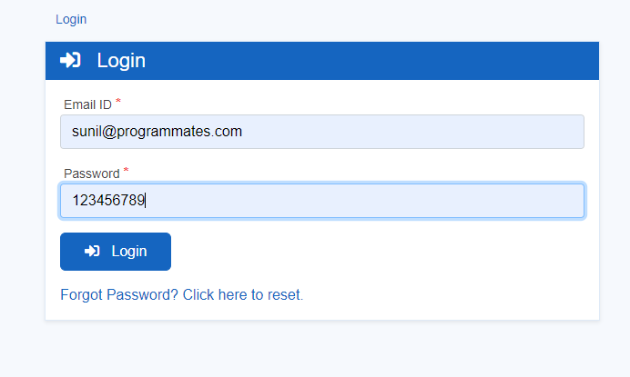

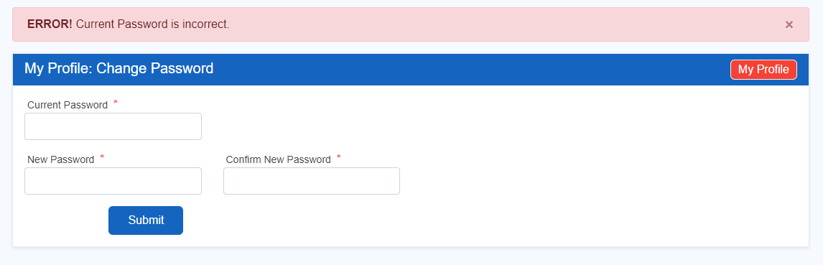

Issue 8 - Admin panel – Upload user csv – All the field are imported but employee type not available **DONE**

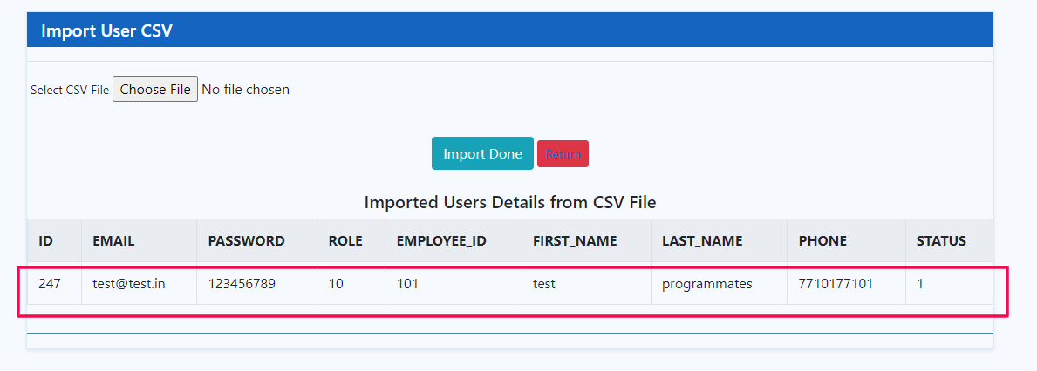

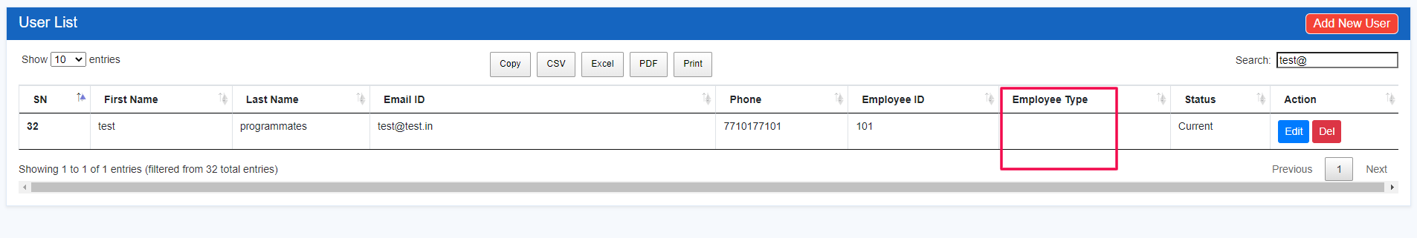

8Th point reply.  
There is issue that in csv there is no suggestion or hint for assign the Role only the is (Administrator => 20 , Project Manager => 20, Sub-Contractor => 50) so you can only put 20,30,50 for that column in csv due to this lack of information Employee type is showing blank if someone put (10 11 12) anything in csv. So we have added example in csv like below screenshot when user download sample csv format.  
  


And if someone add same email address in csv there is not alert message or information that these mail id’s are duplicate So that time system look like not working. So we check the code and add this message when entering existing mail ID’s.  
  
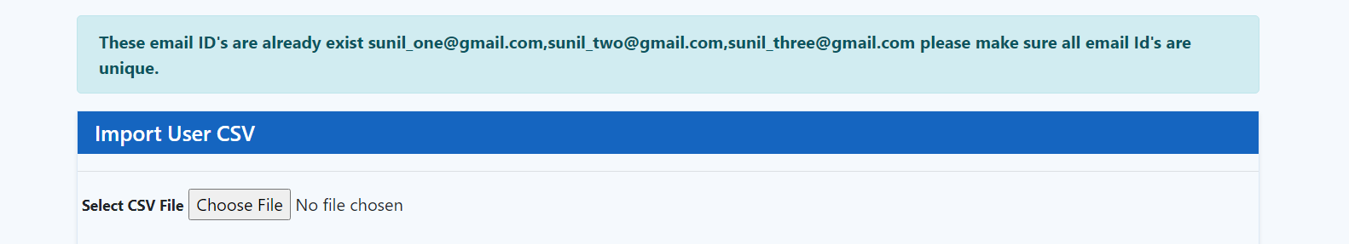

Issue 9 - Admin panel – upload job csv – All the field are imported but project manager not available **DONE**

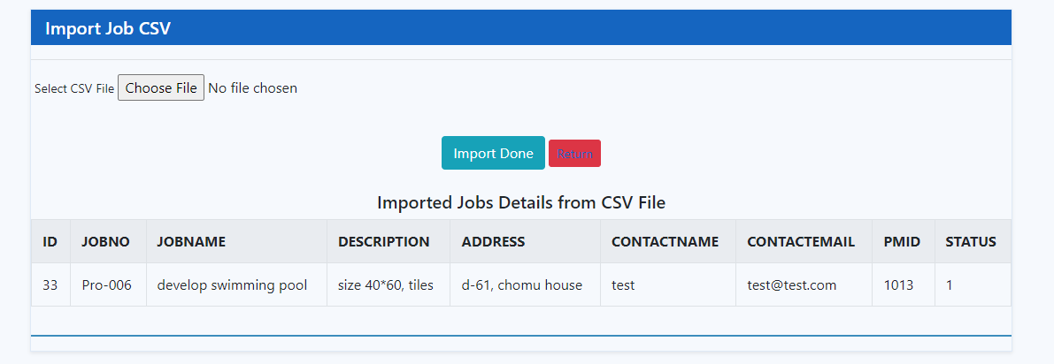

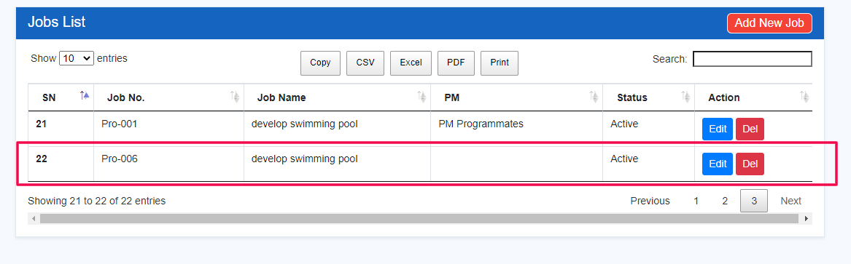

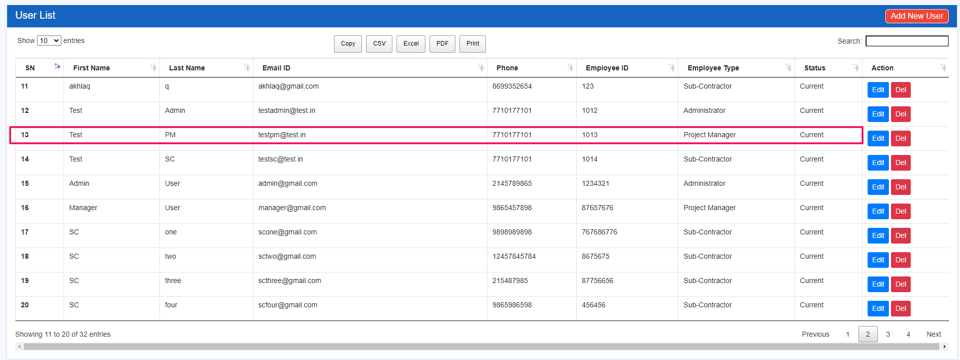

**Solution:- In this issue you are using employee ID to insert job in database but its not related to any query so we have provided a new column for user Id which will be used as user id in sample csv file.**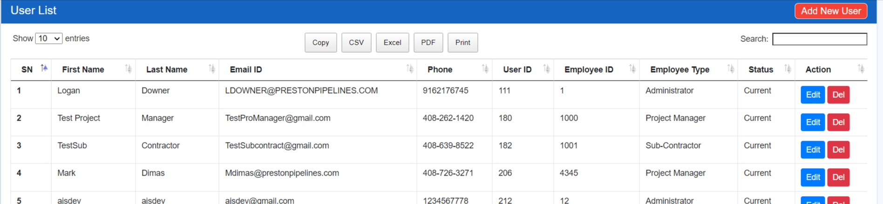

Next time when you want to upload job csv then need to put User ID only.

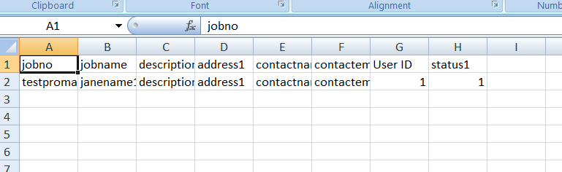

Issue 10 - Admin panel – user/job import – menu redirected to 404 pages **DONE**

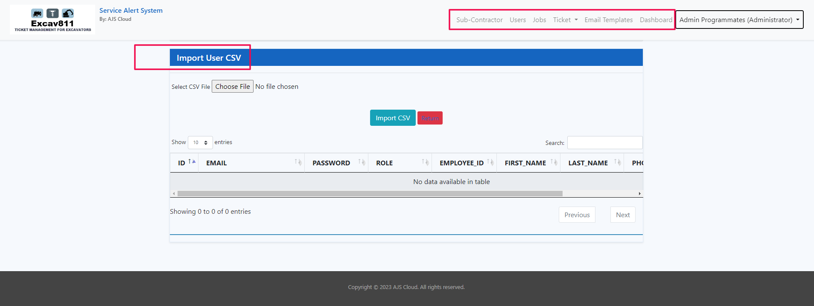

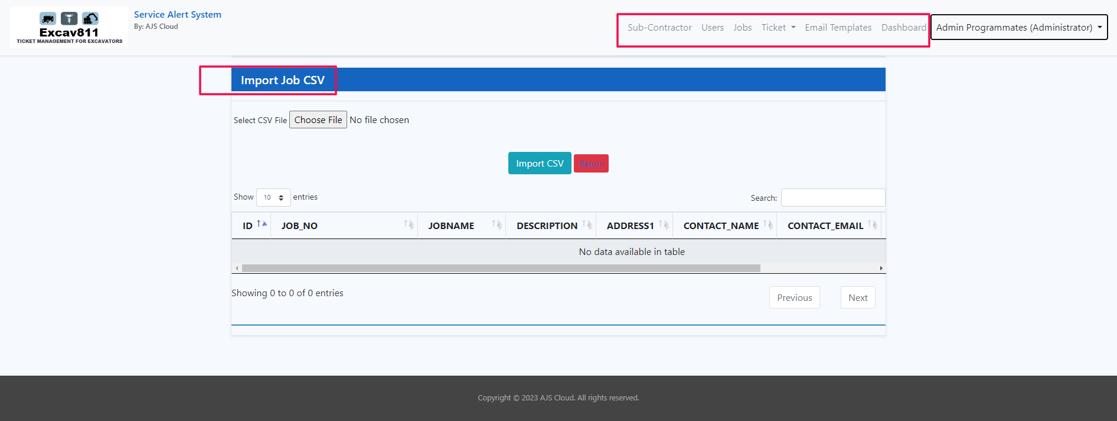

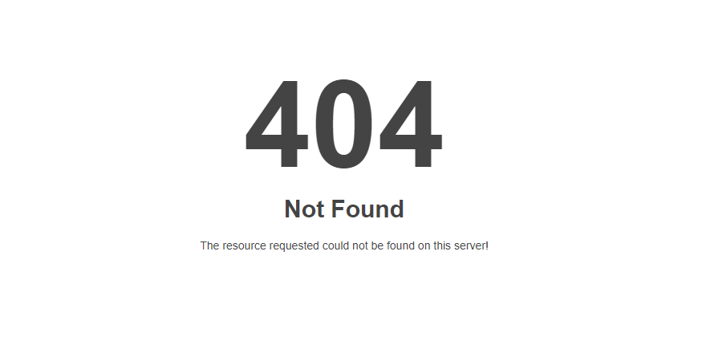

Issue 11 - Admin panel – add user – if we insert alphanumeric value to “Employee ID” then user created with “Employee ID” = 0 **DONE**

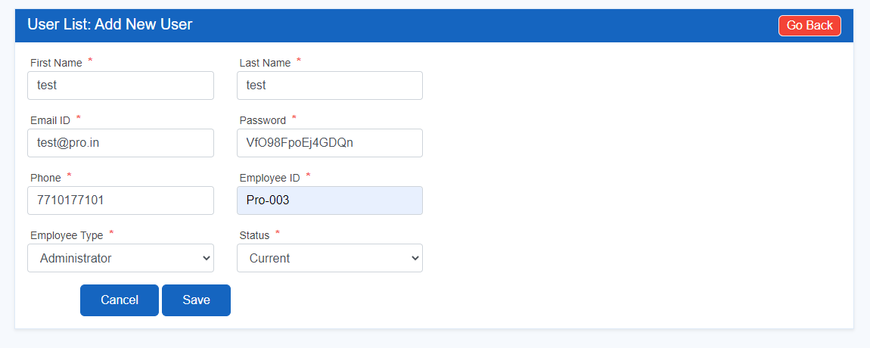

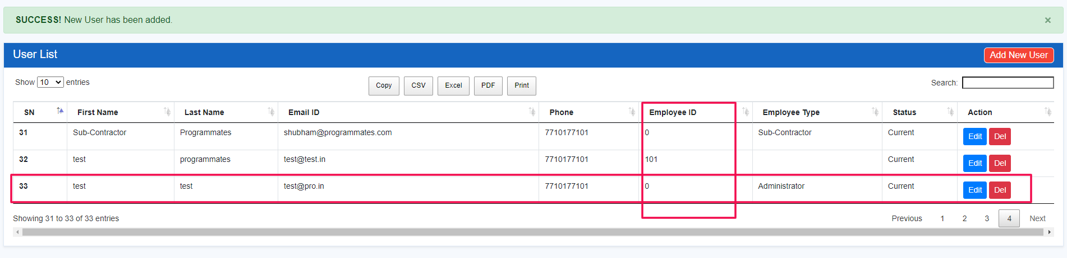

Issue 12 – Admin panel – Dashboard – not able to clear the dates of search bar **DONE**

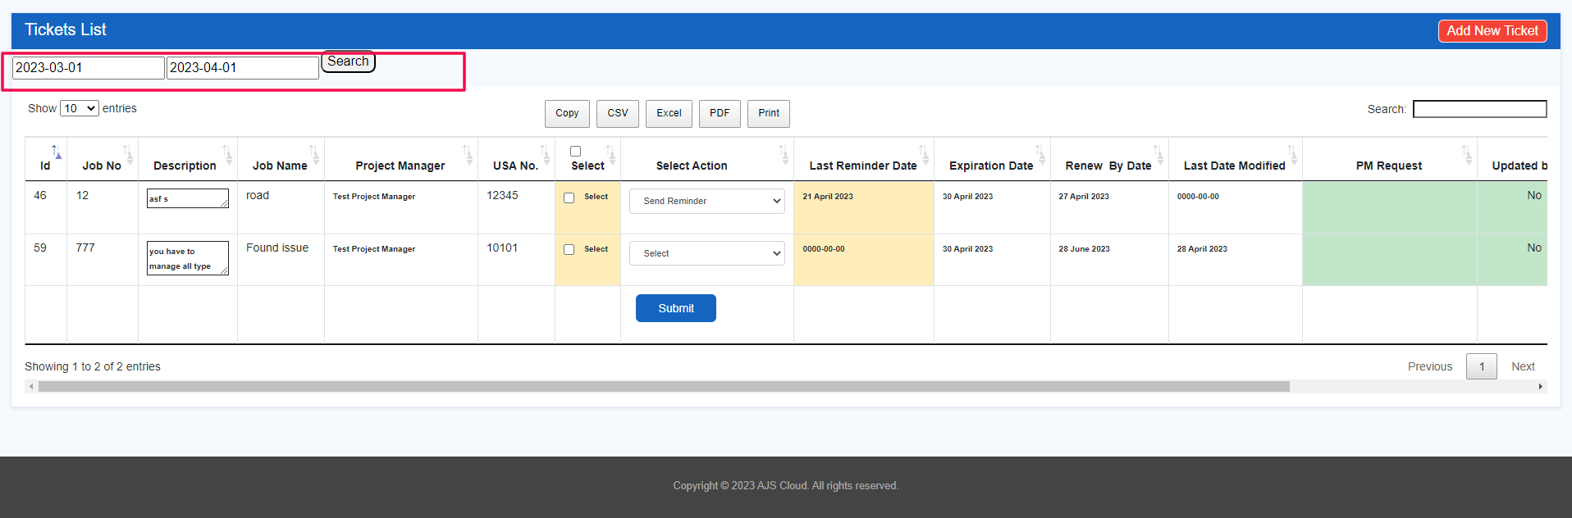

Issue 13 – Admin panel – Dashboard – tickets automatically not expire after expiry date over

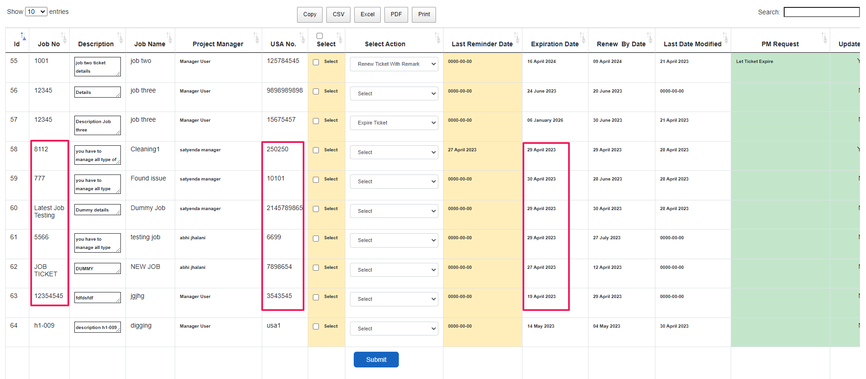

Issue 14 – Admin panel – Dashboard – search section not generate result for field - “select action”

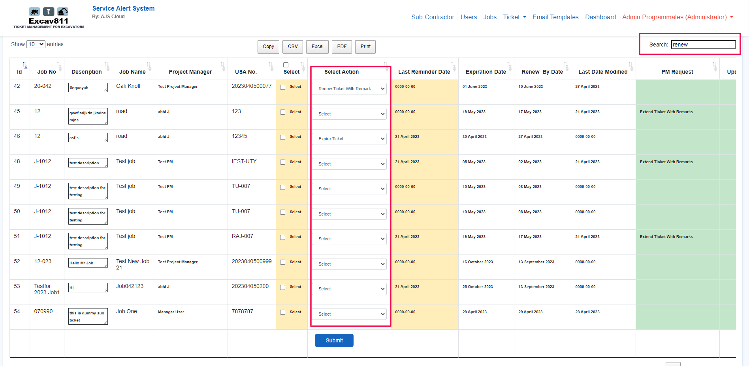

Issue 15 – Admin panel – Dashboard – Export ticket data in format of CSV, Excel or PDF then “select action” field shows all the drop-down option in export file, instead of selected option

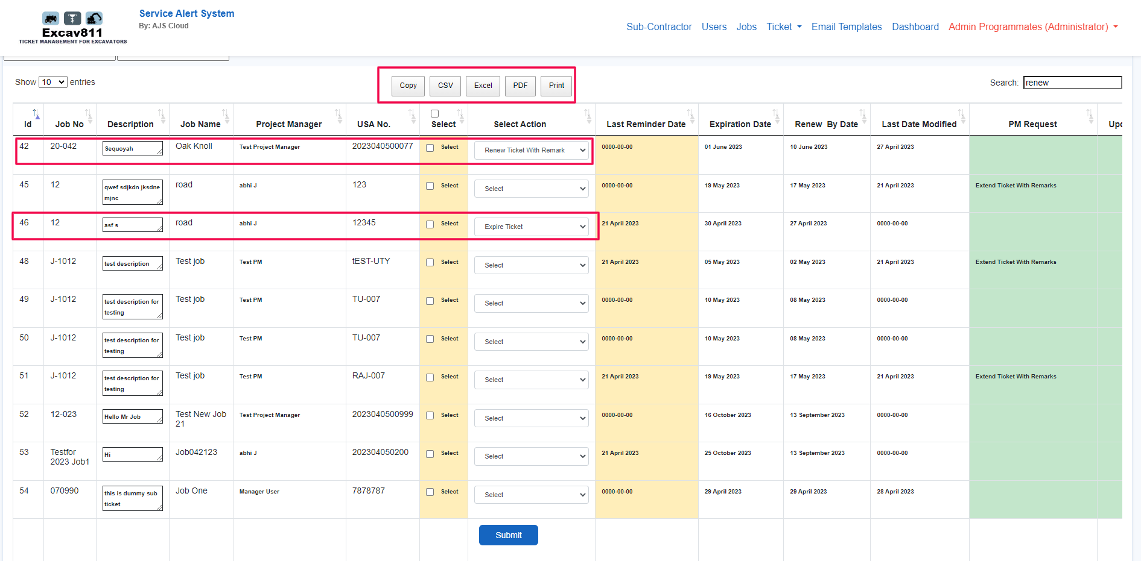

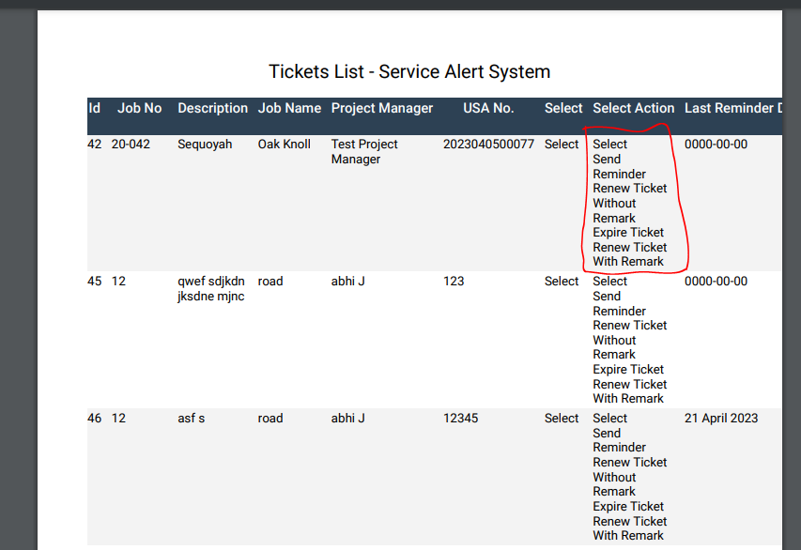

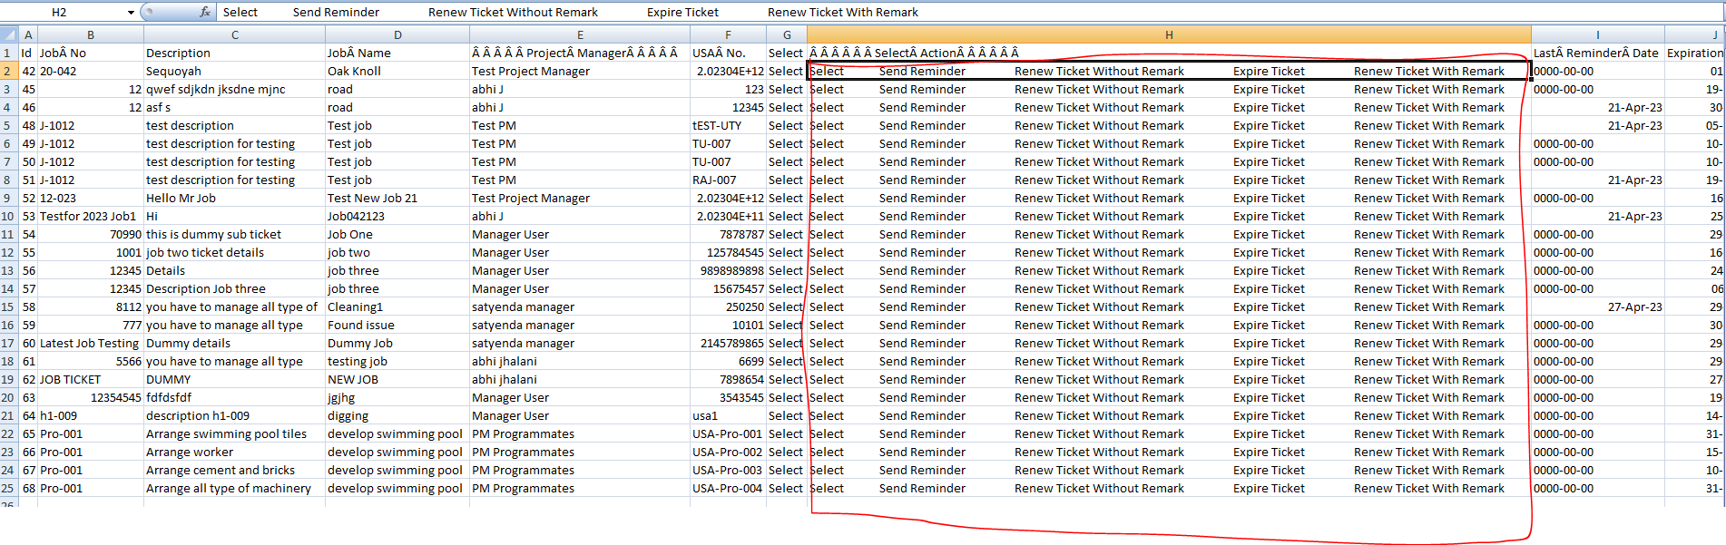

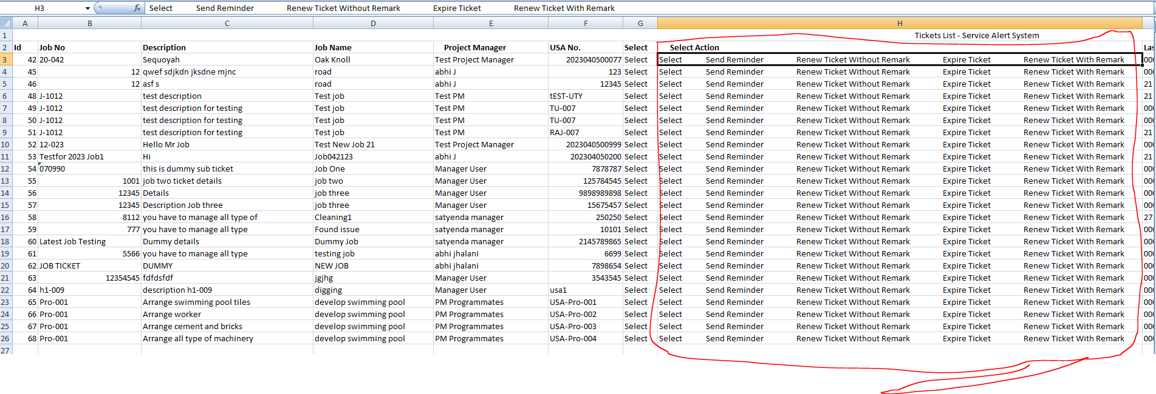

Issue 16 – Admin panel – Export any file format of user, sub contractor or any other export, in that “action button” field also exported **DONE**

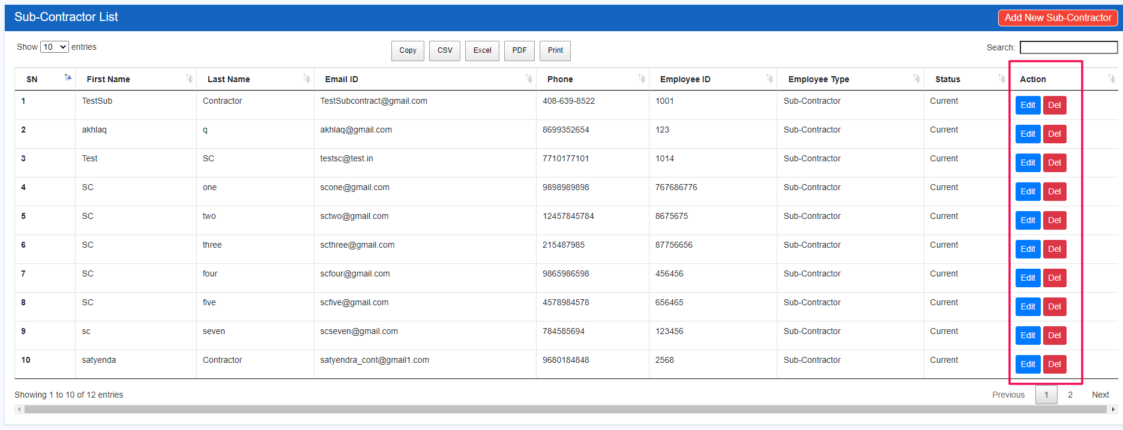

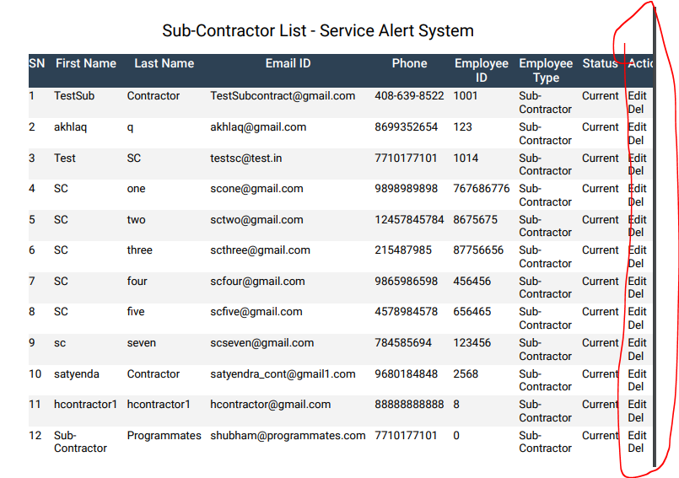

Issue 17 – Admin panel – Ticket expire – wrong message shows on ticket expire

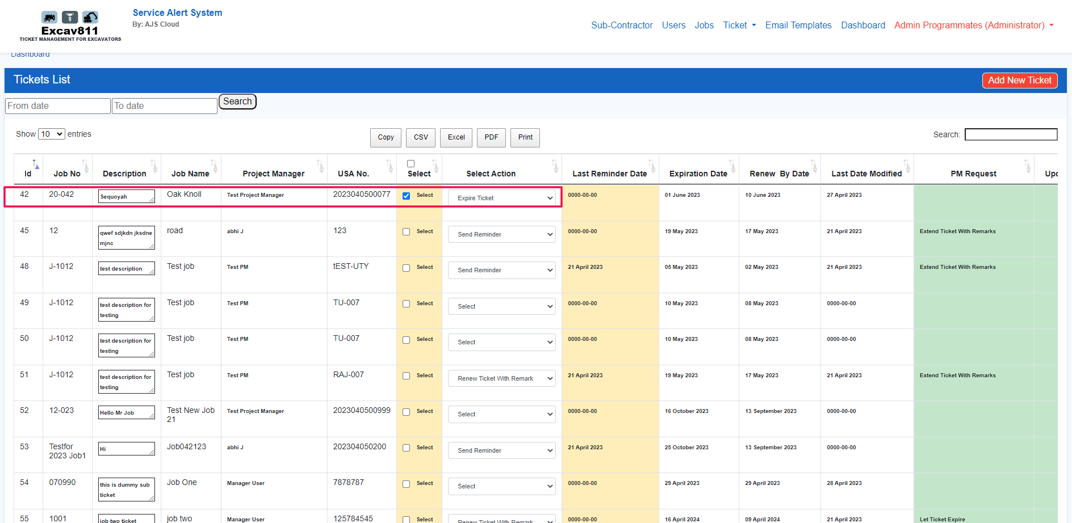

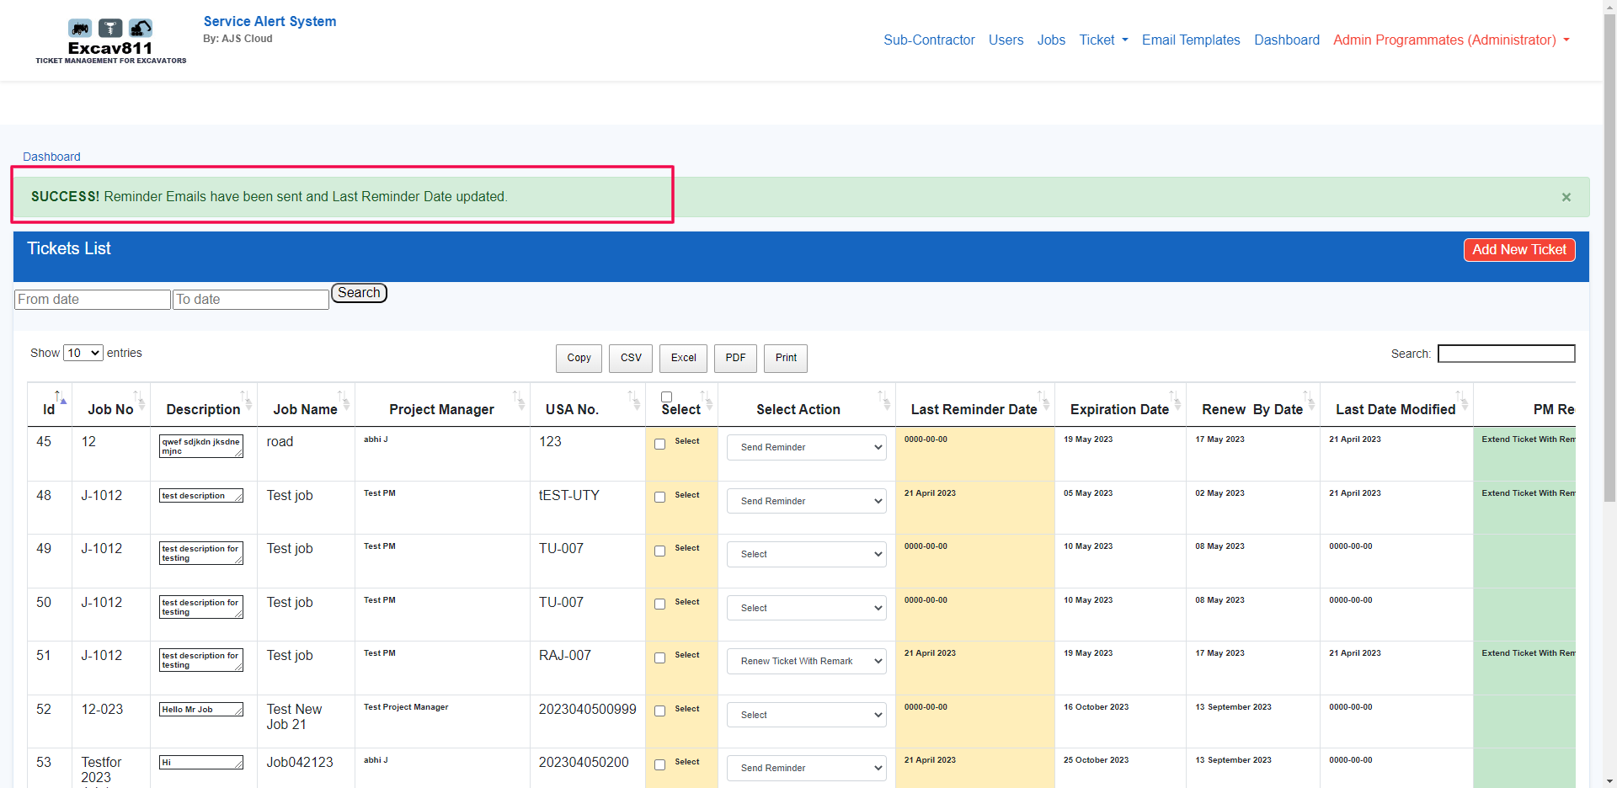

Issue 18 – Admin panel – Ticket history – PDF export – All field not exported

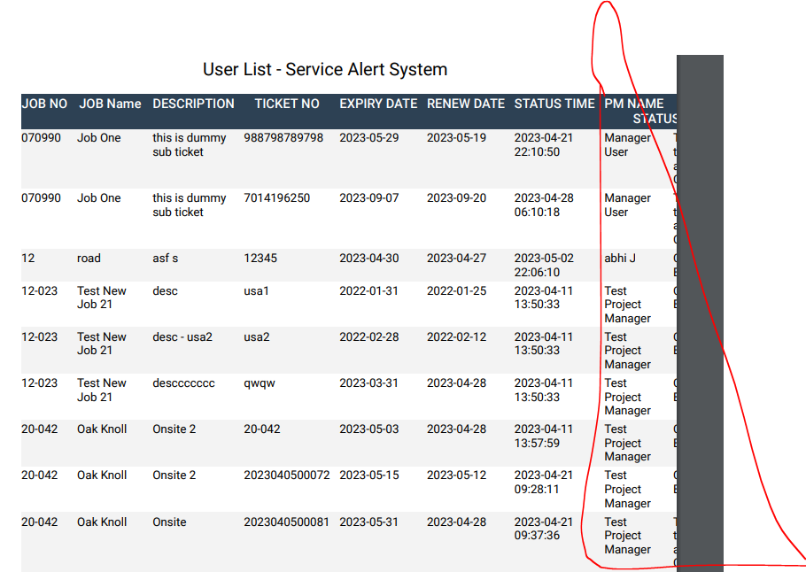

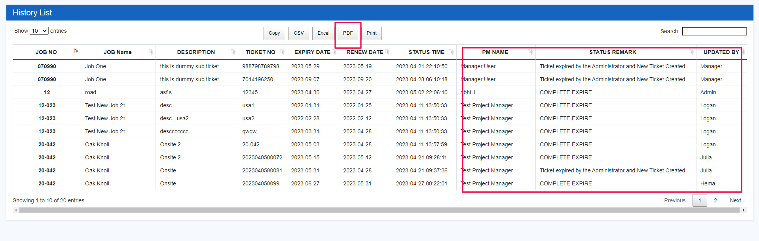

Issue 19 – Admin panel – create user – if we try to create new user with existing email-id then getting but error message is not correct

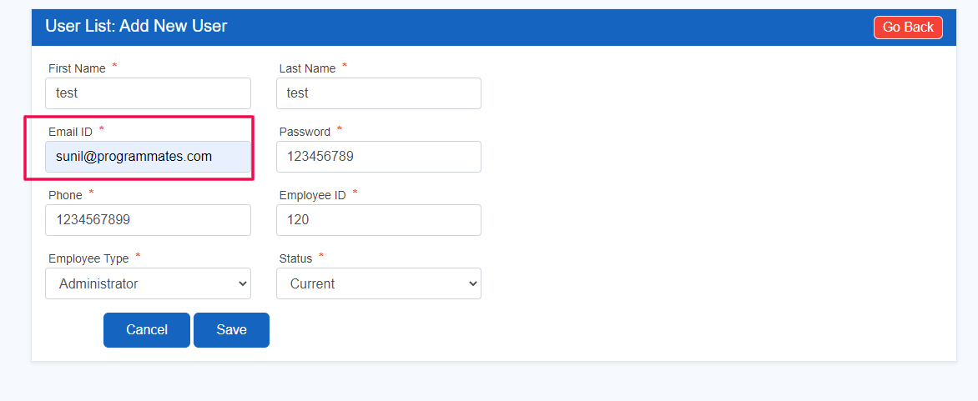

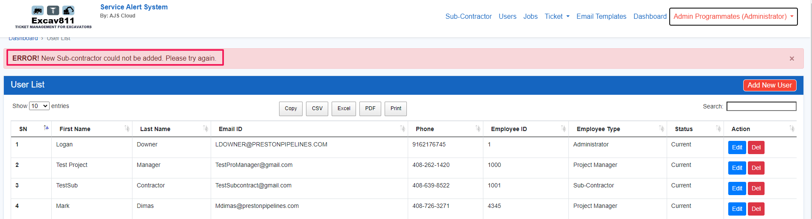

Issue 20 – Admin panel – Edit ticket – New ticket – calendar not available

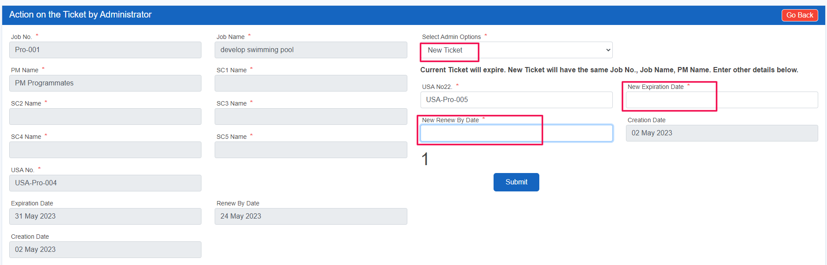

Issue 21 – Admin panel - Edit ticket – New ticket – manual enter date saved but in listing wrong date shows

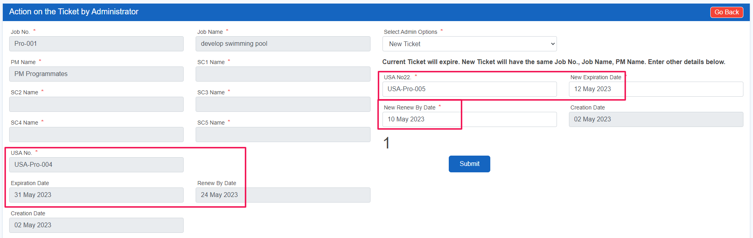

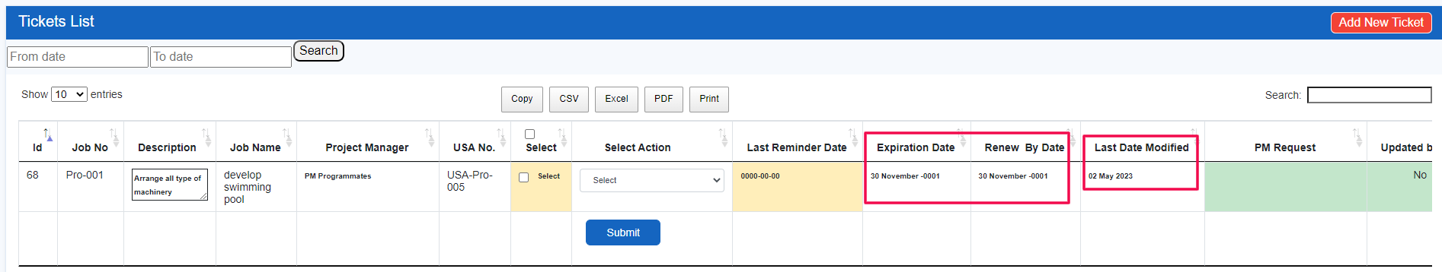

Issue 22 – Admin panel – users – Employee ID is same for 2 users

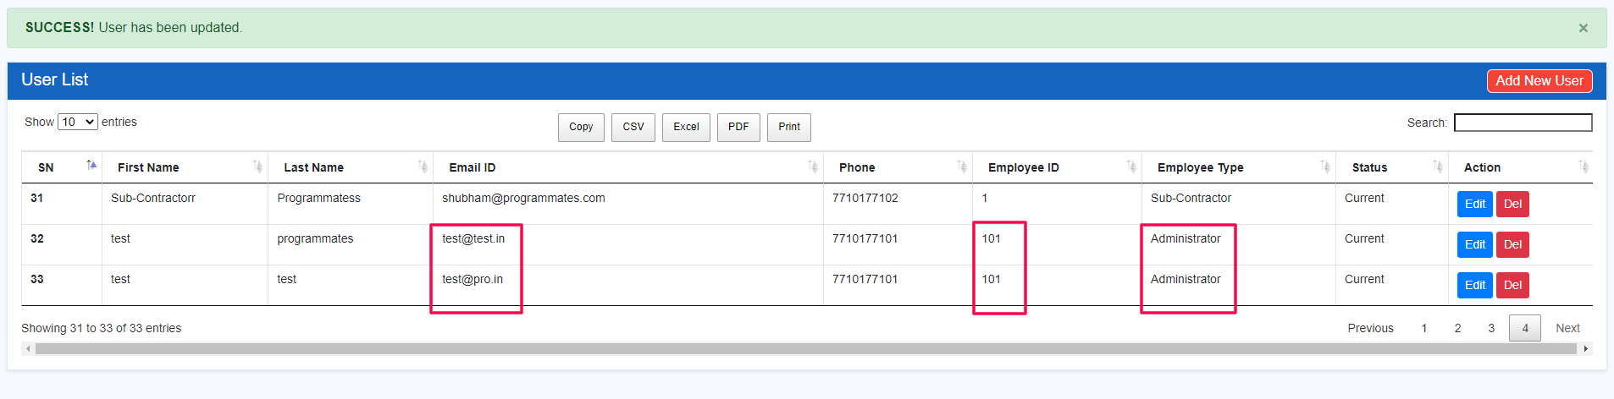

Issue 23 – Admin panel – if we delete the PM of existing assignee tickets then tickets also expired (move to ticket history)

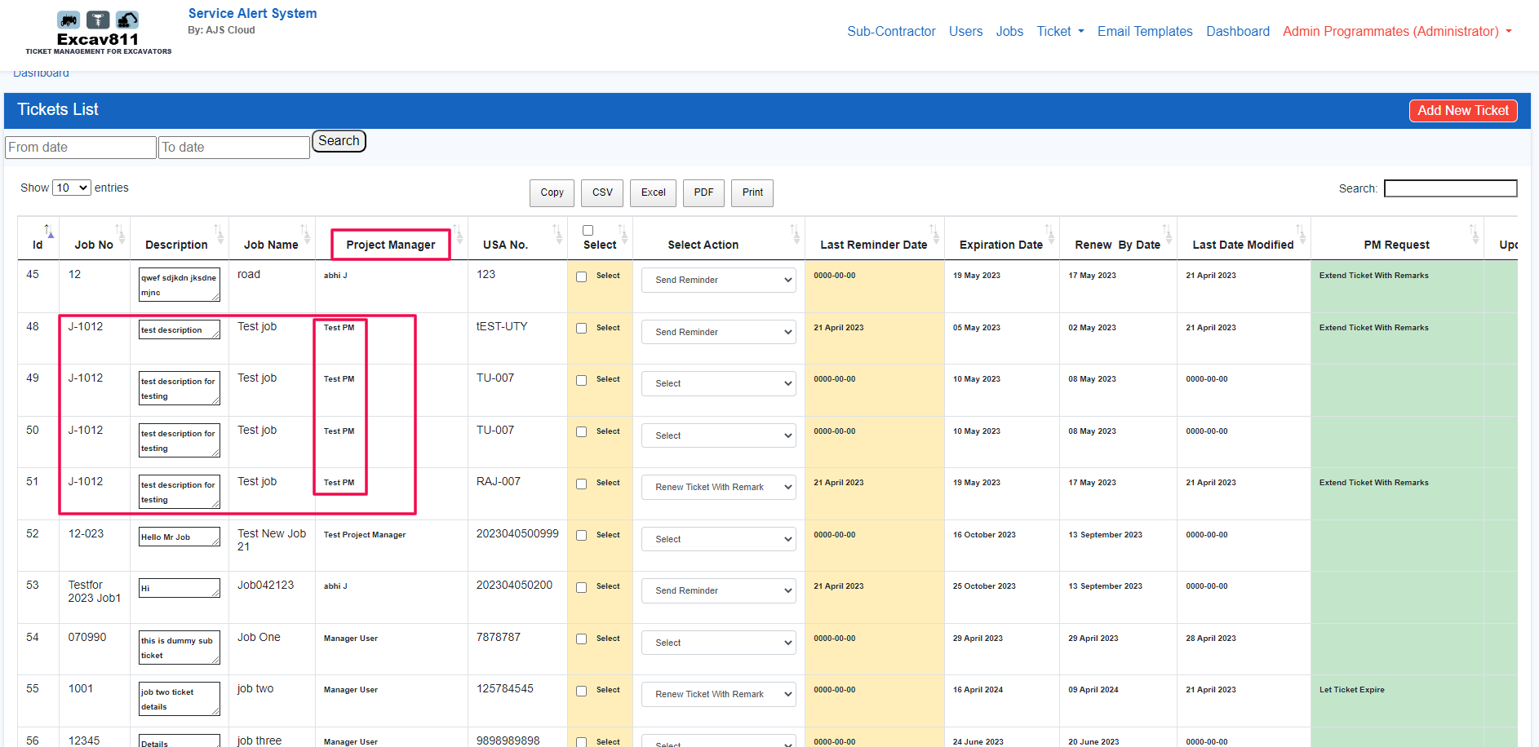

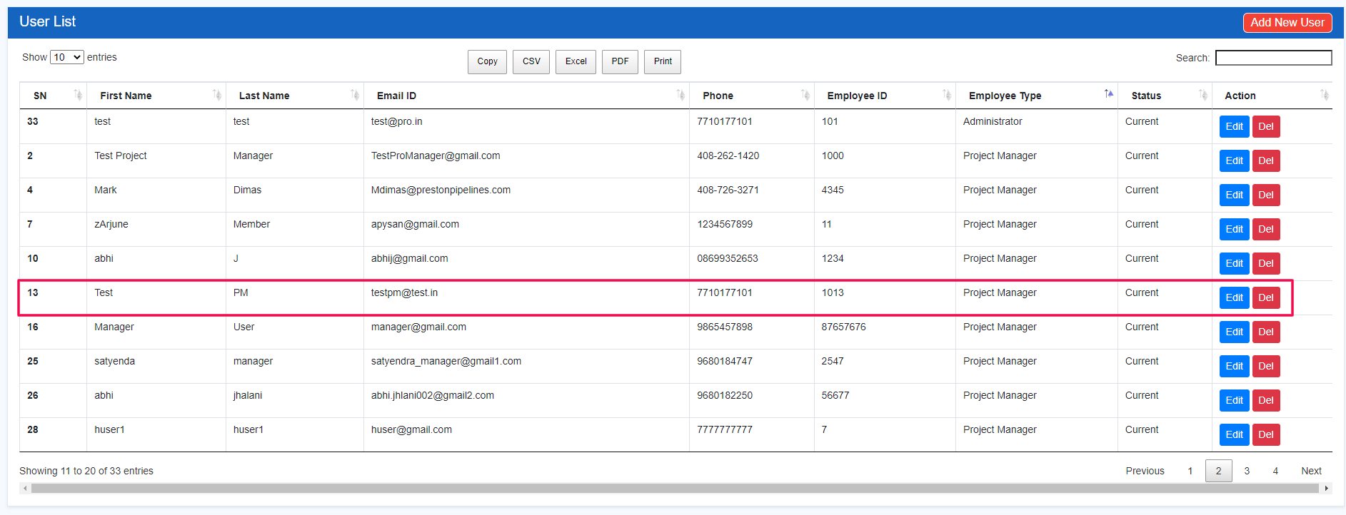

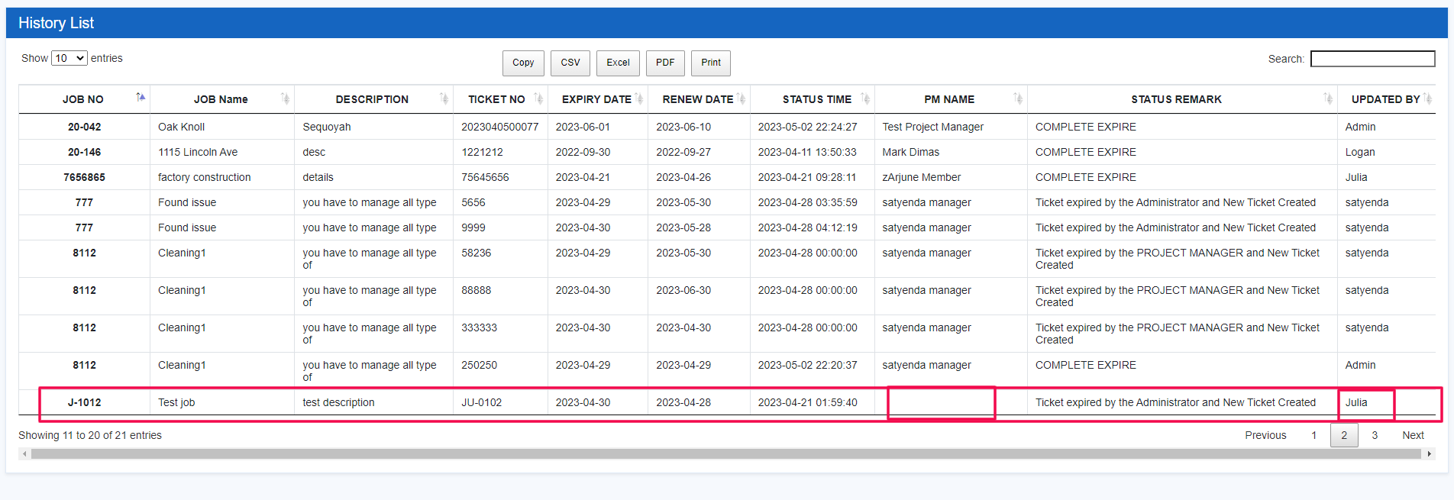

Issue 24 – Admin panel – password reset – password reset successfully done but after that not able to login **DONE**

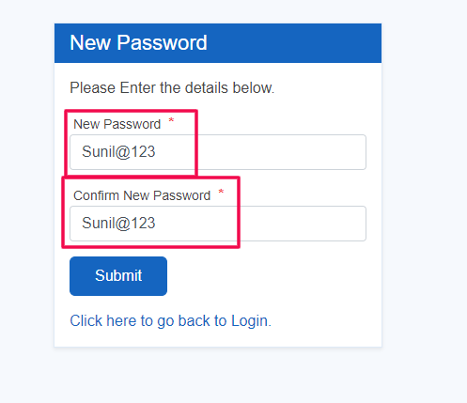 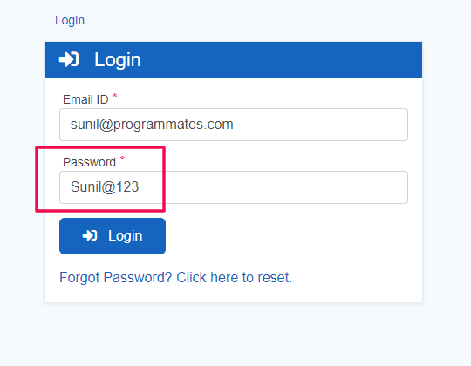

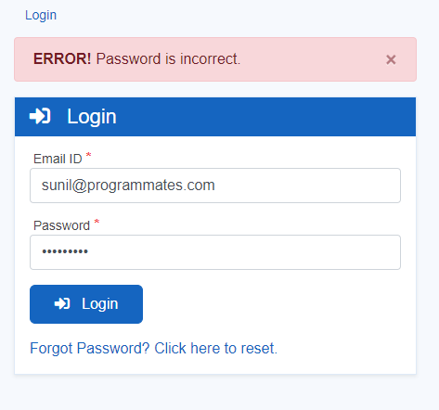

Issue 25 – Admin panel – Tickets – select action as send reminder and after submit getting message of reminder email has been sent but PM not received any email.

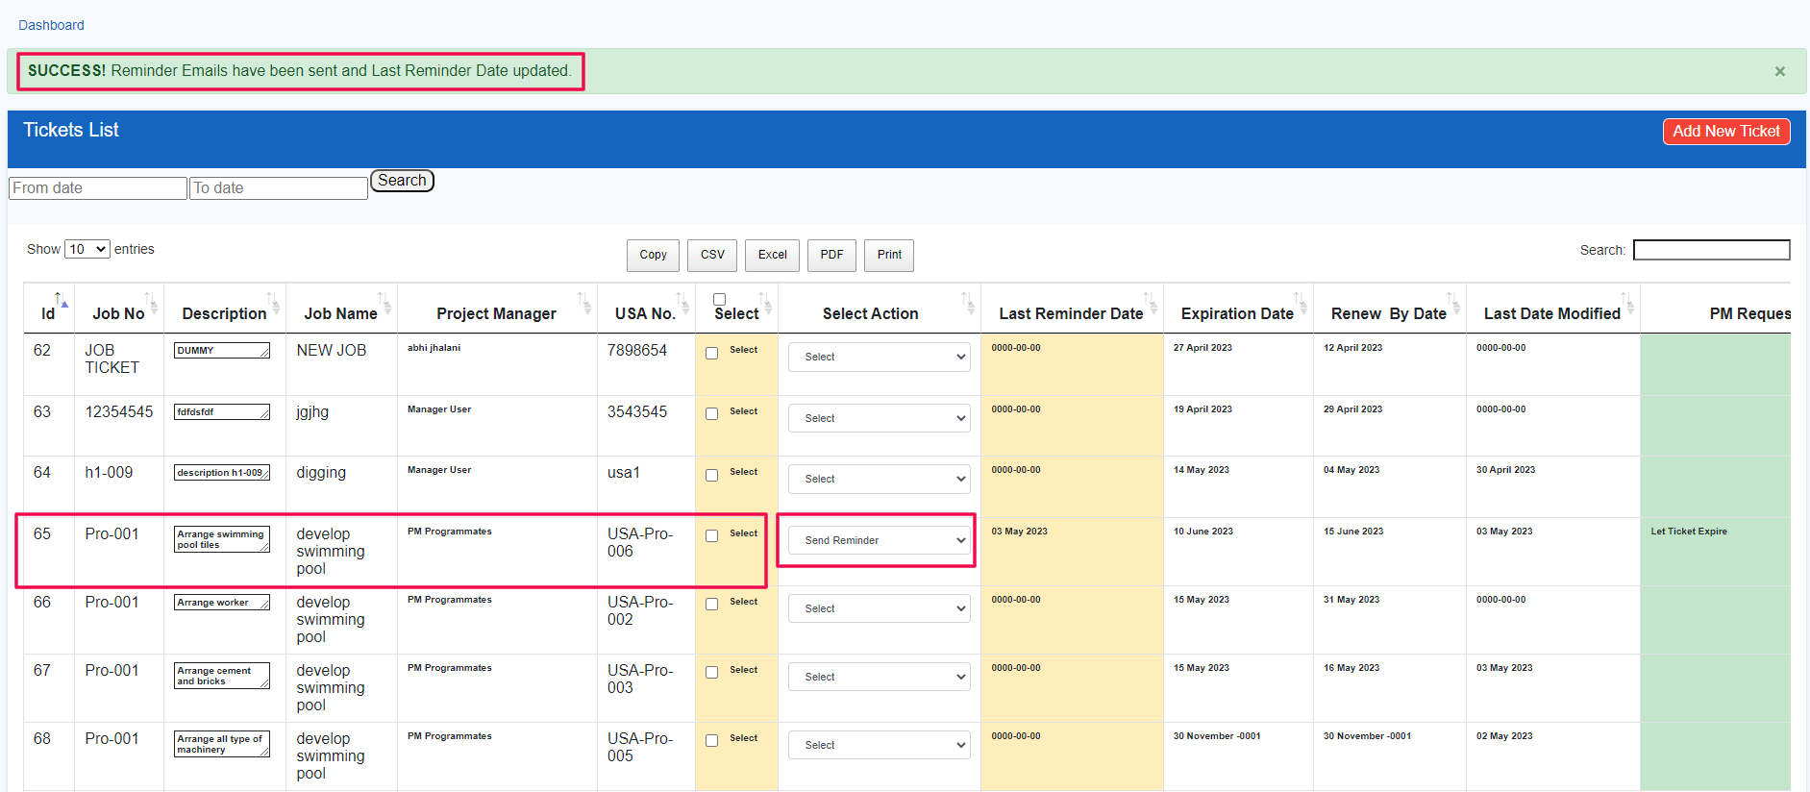

Issue 26 – Admin panel – Ticket – “select action” by that email not received (same as above issue)

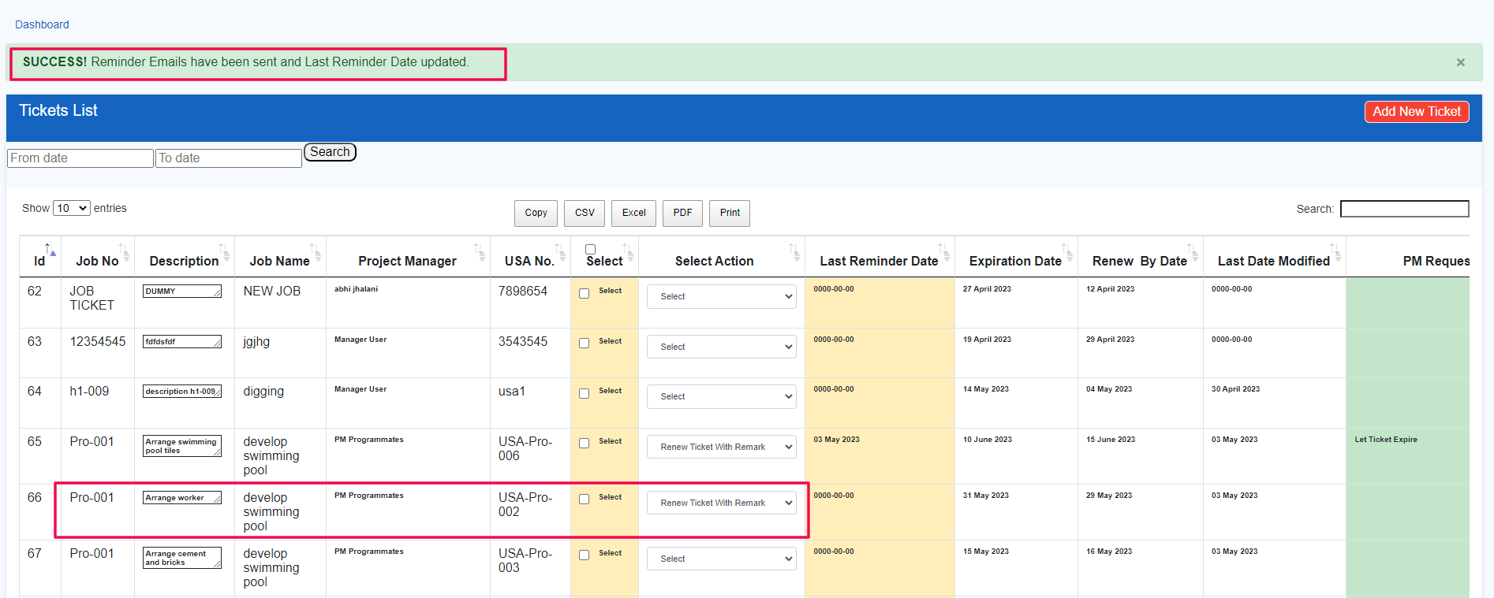

Issue 27 – PM panel – Change password – not able to change password getting error of “current password is wrong” **DONE**

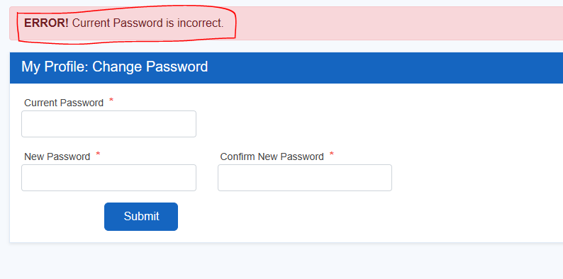

Issue 28 – SC panel – Change password – not able to change password getting error of “current password is wrong” **DONE**

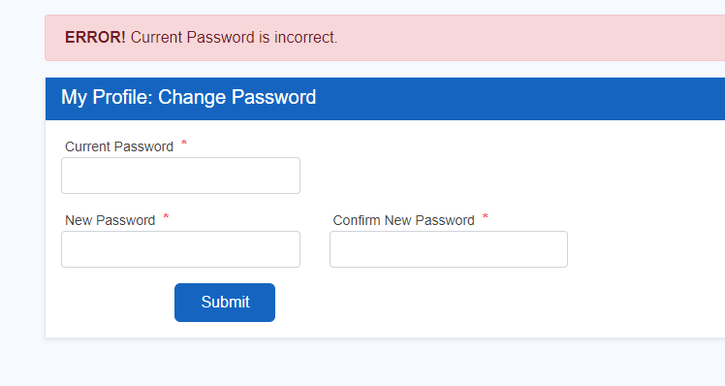

Issue 29 – PM panel – forget password – After change password successfully not able to login **DONE**

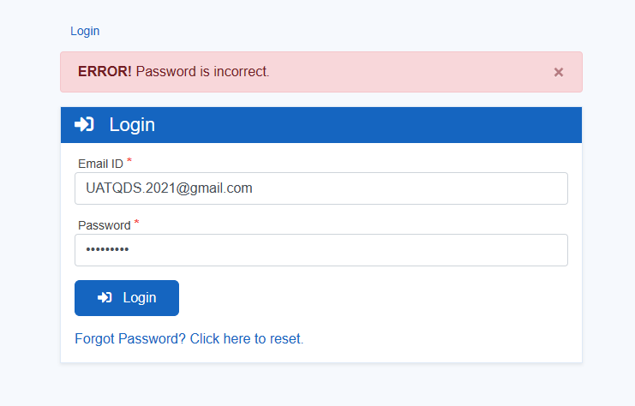

Issue 30 – SC panel – forget password – After change password successfully not able to login **DONE**

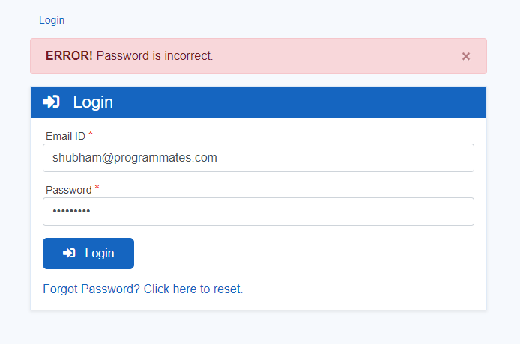

Issue 31 – Admin panel – Dashboard – Sorting result is not correct for all dates field

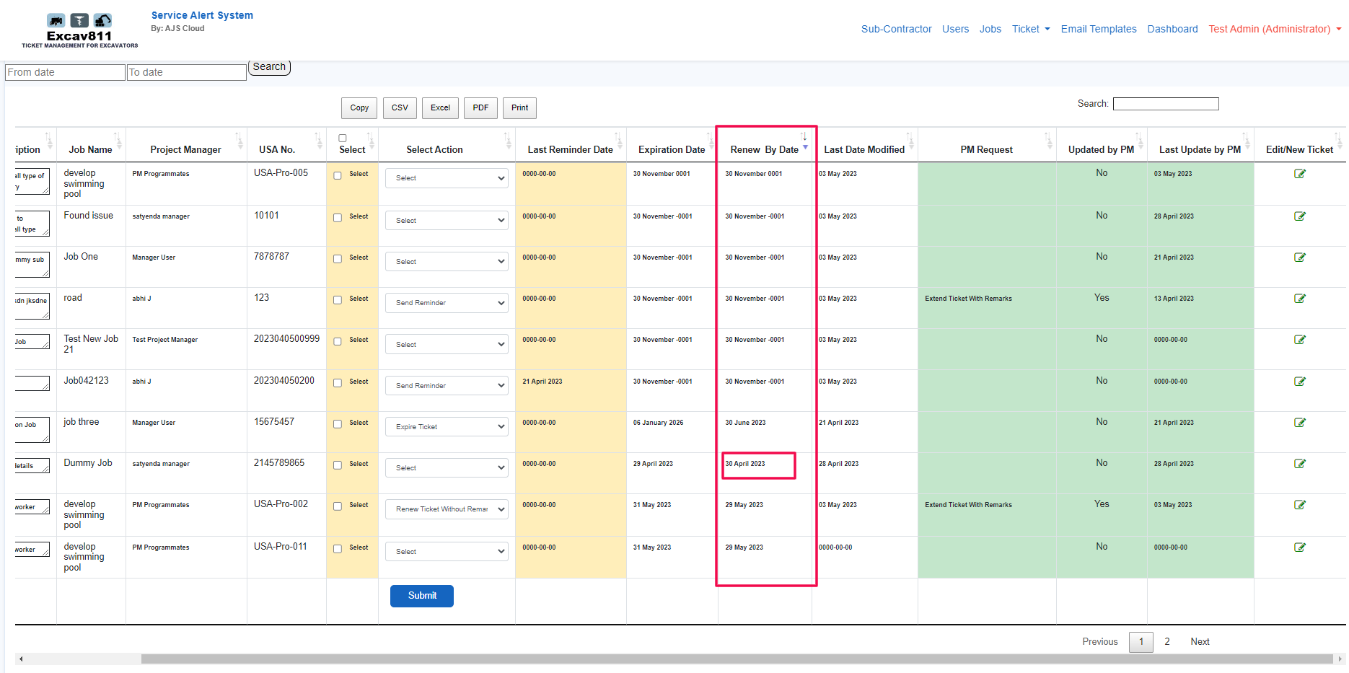

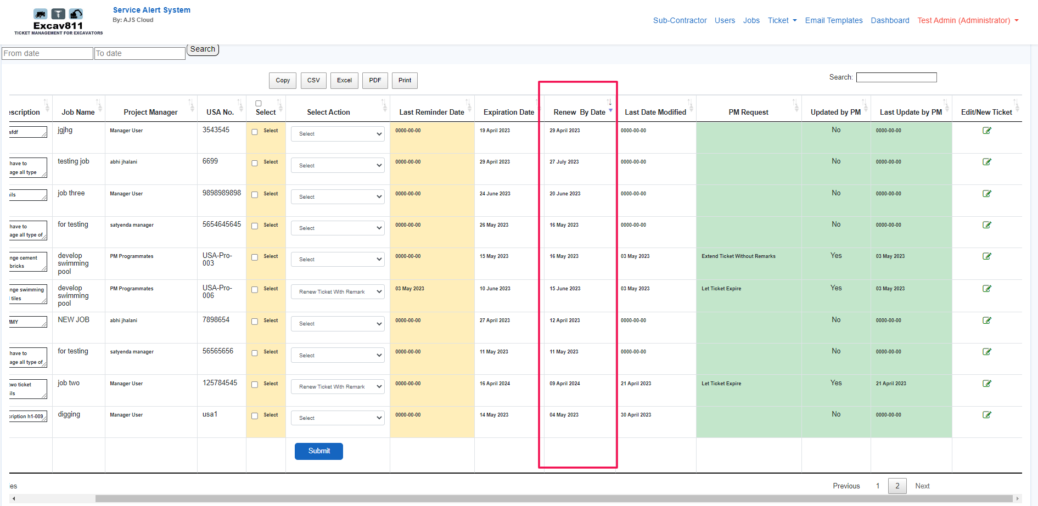

Issue 32 – Admin panel – Dashboard – As per document – “The reminder button will only available in case PM did not respond and “Update by PM” button is marked as “No”” but here reminder button is available and working also

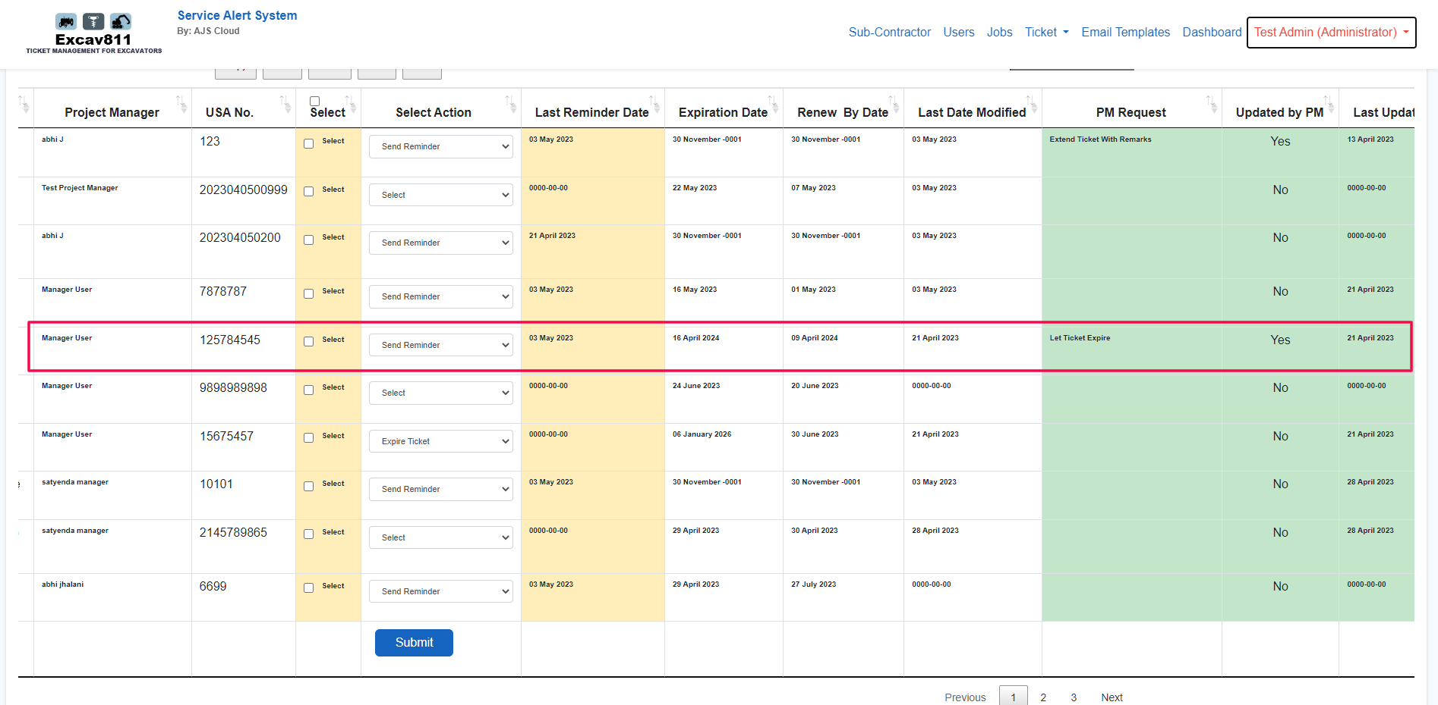

Issue 33 – Admin panel – Edit ticket – As per document – “both Update Exp and New ticket from existing will copy the history to ticket history tab.” – after submit, ticket updated but this ticket old details not move to ticket history

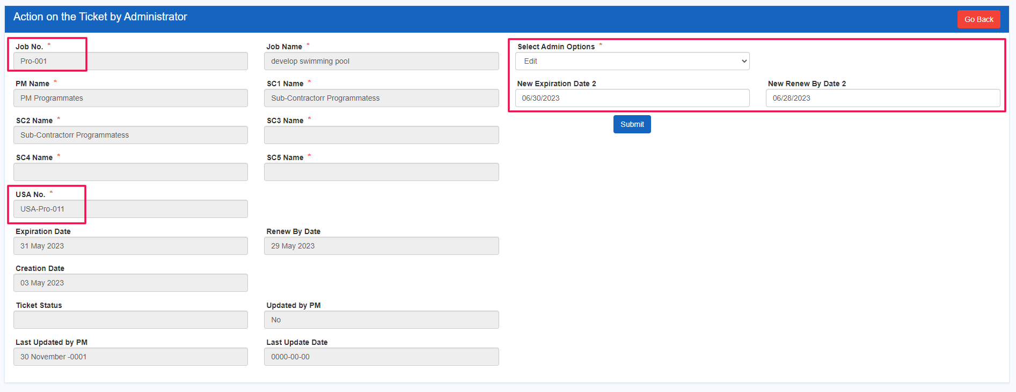

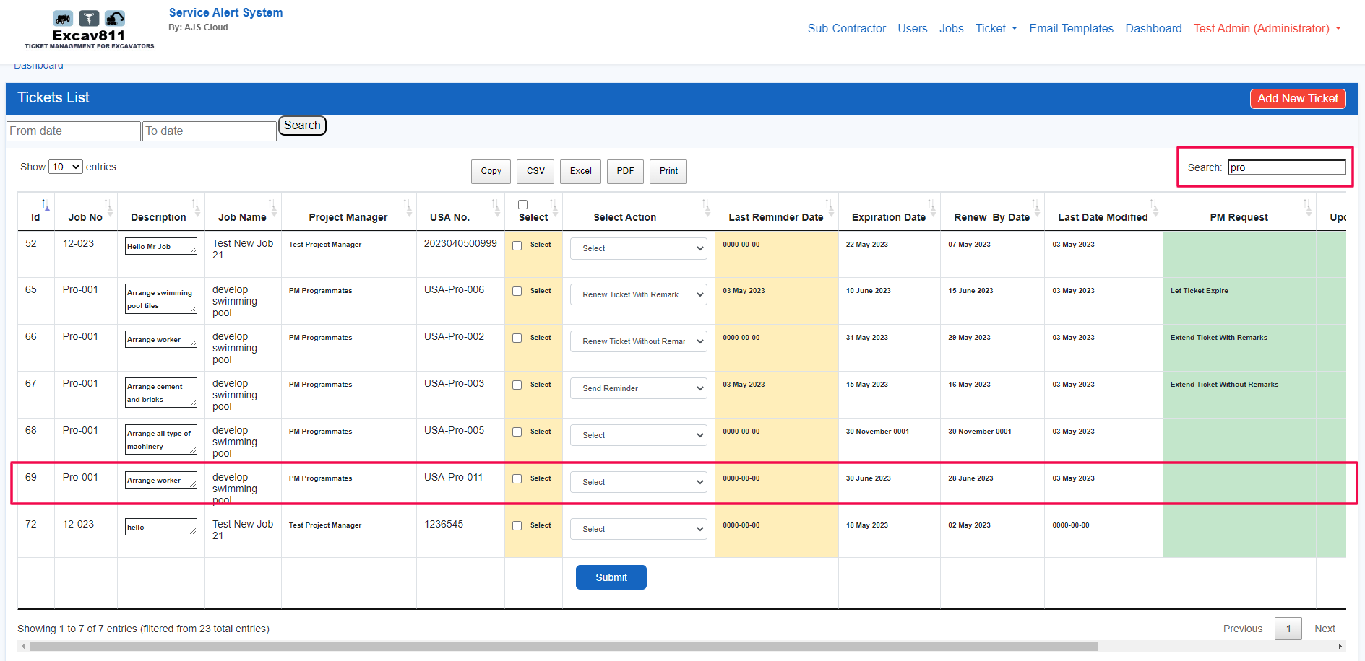

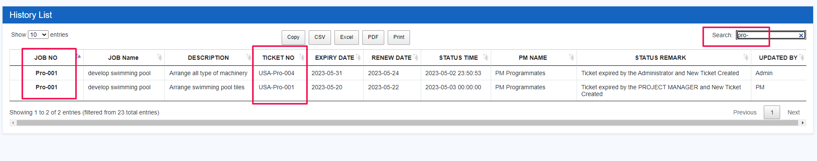

**Query’s for client –**

Query 1 – SC panel – Edit ticket – new ticket – After submit its move to “active sub ticket” but current ticket is still visible at PM and Admin panel

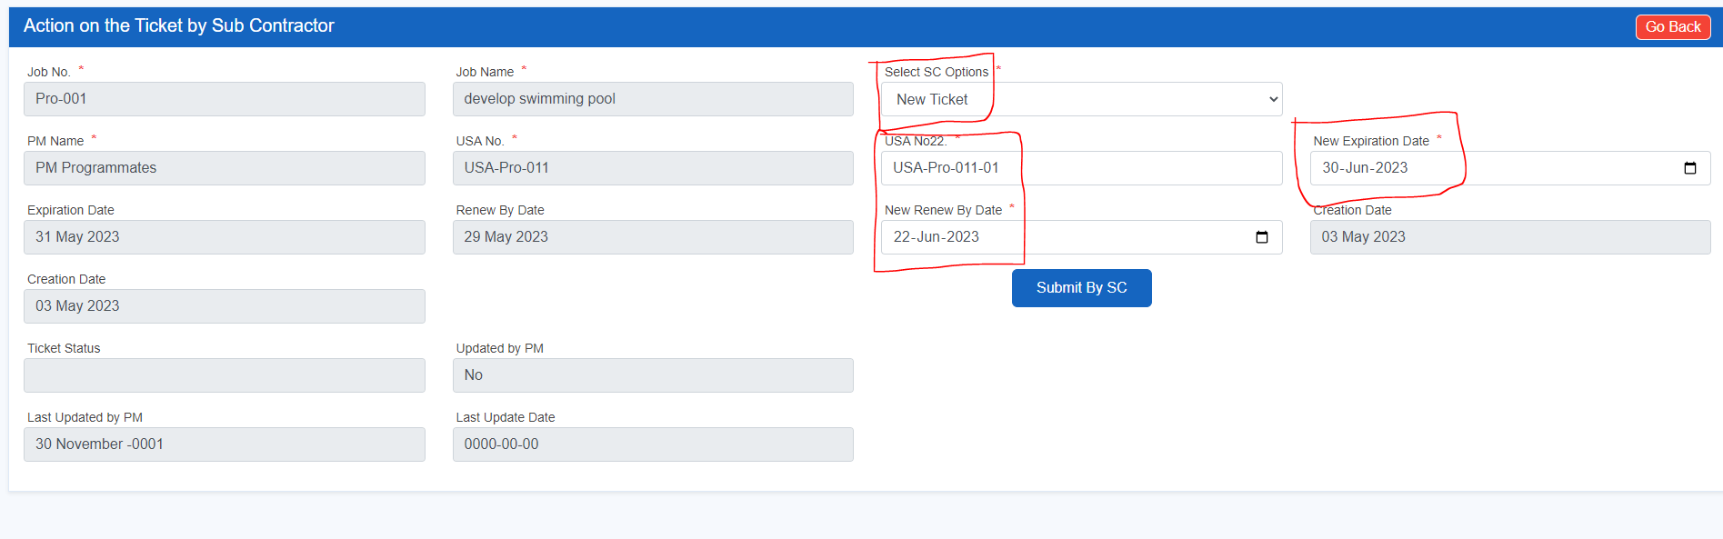

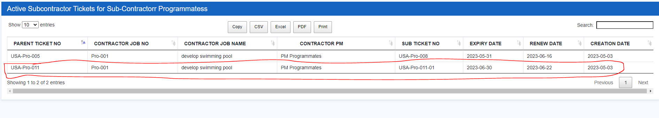

At PM panel

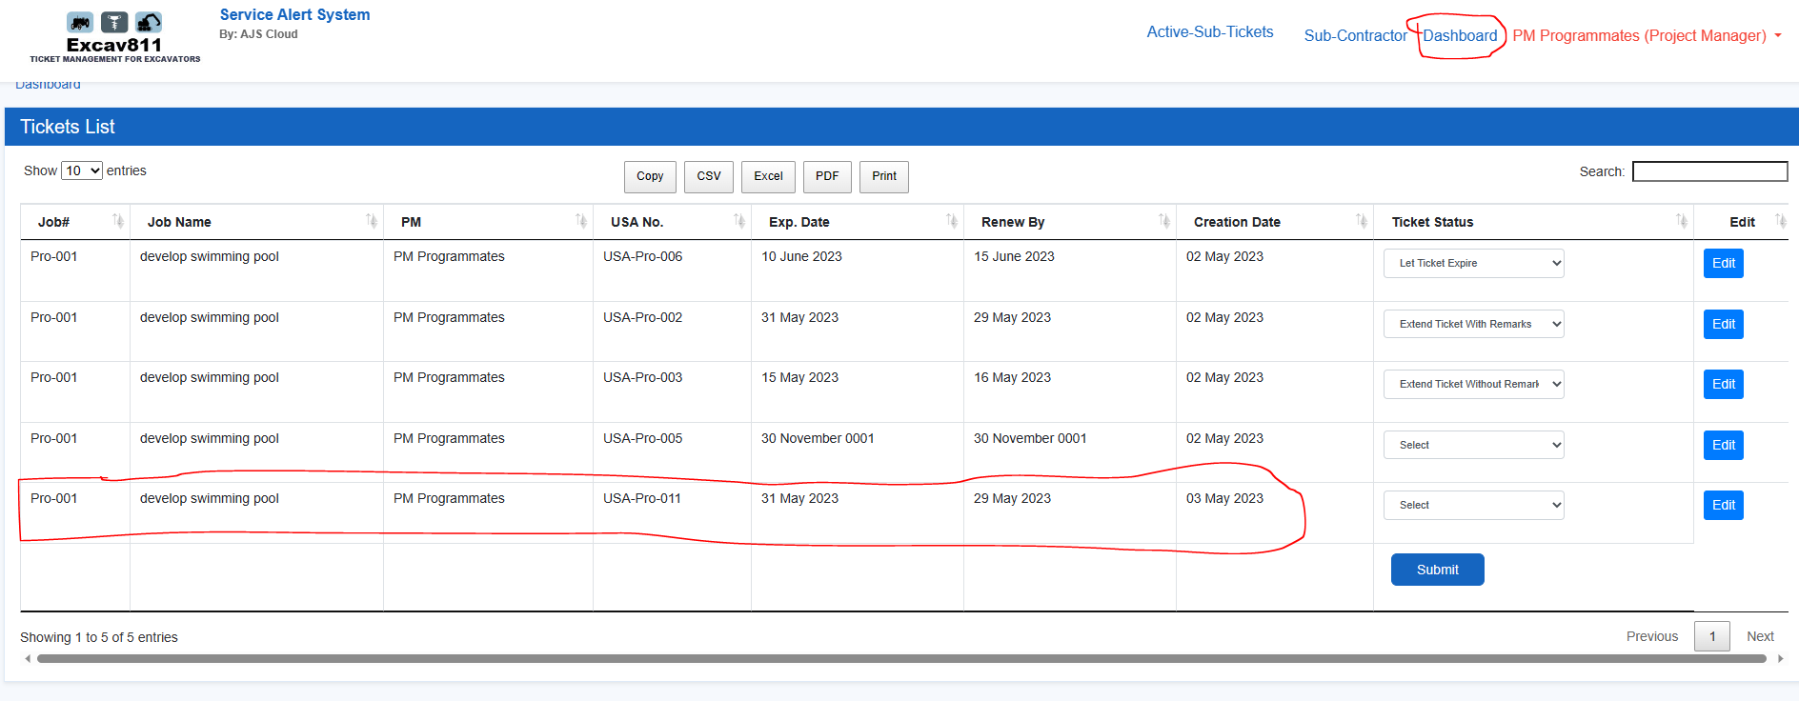

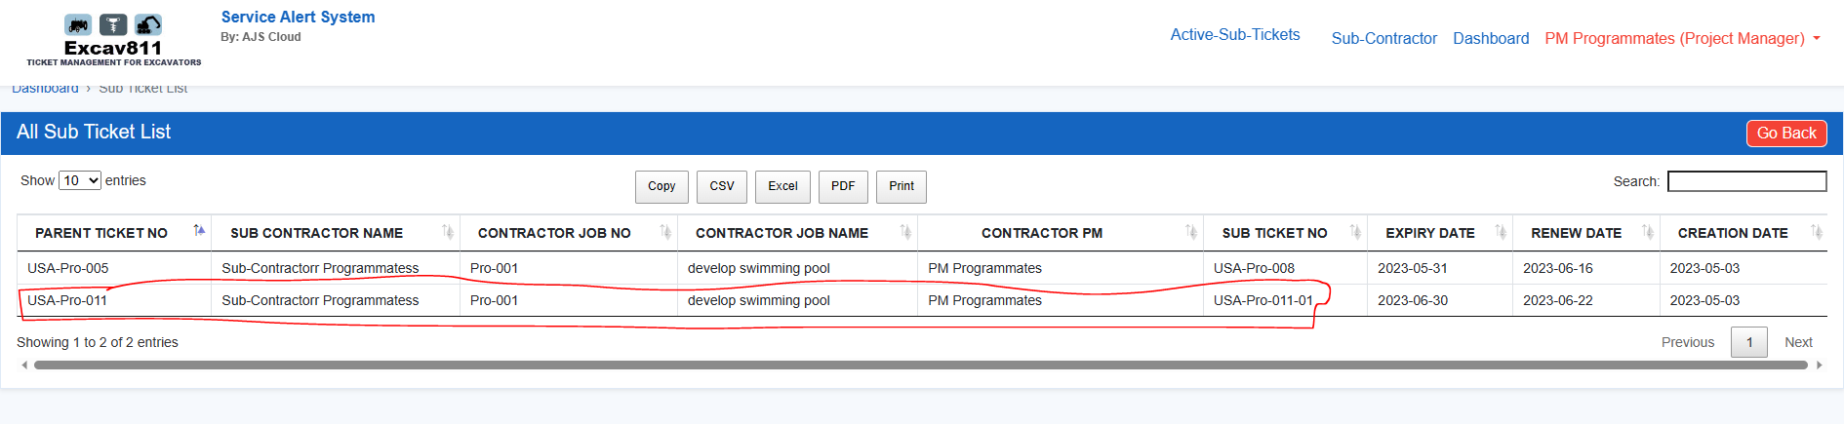

At Admin panel

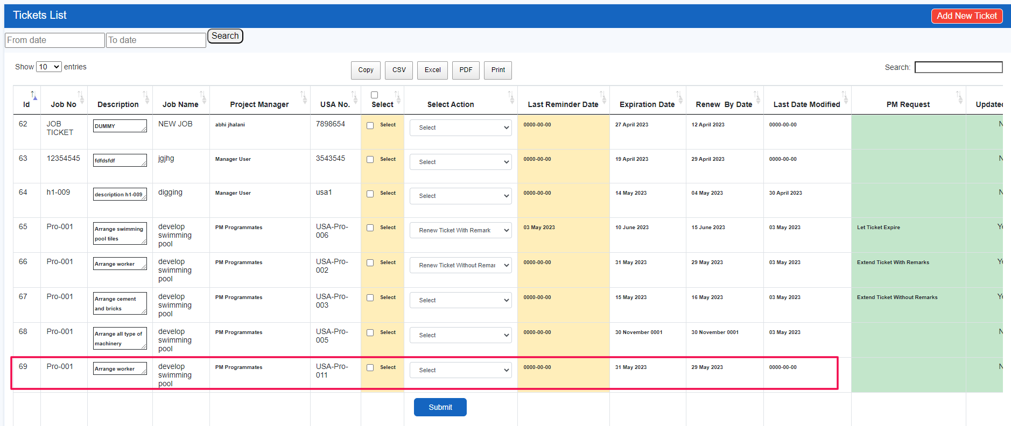

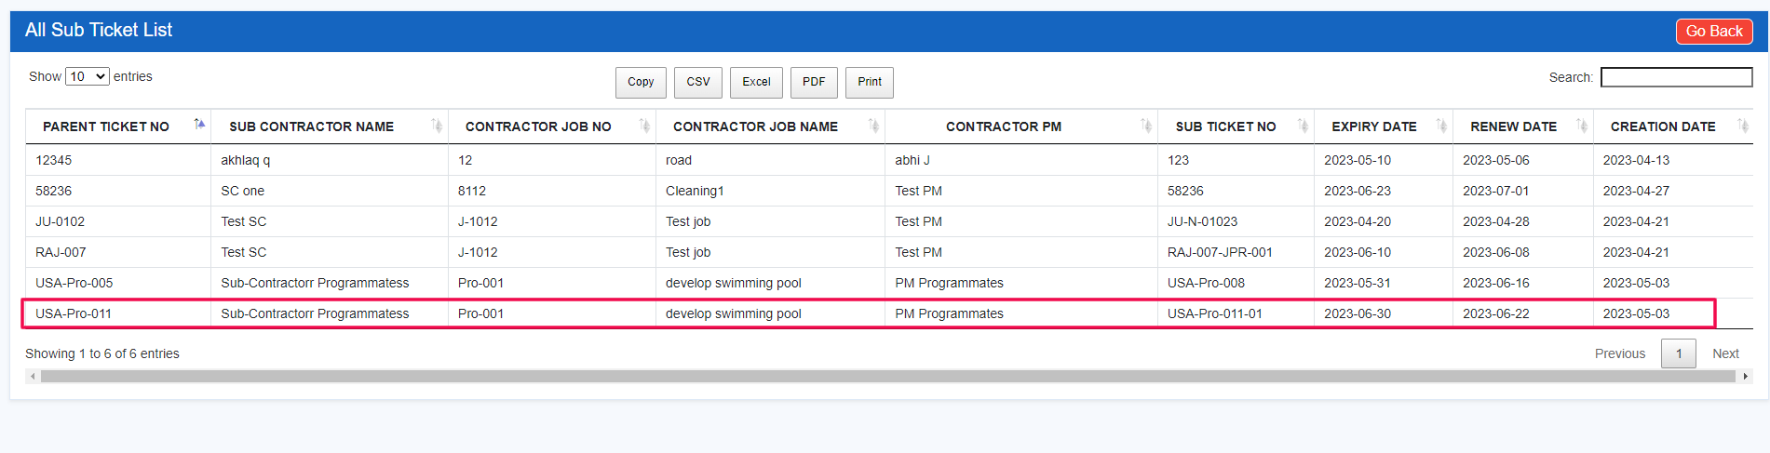

Query 2 – SC panel – Sub ticket – Sub ticket are read only

